This example is taken from <https://www.tensorflow.org/api_guides/cc/guide>

// tensorflow/cc/example/example.cc  
  
#include "tensorflow/cc/client/client_session.h"  
#include "tensorflow/cc/ops/standard_ops.h"  
#include "tensorflow/core/framework/tensor.h"  
  
int main() {  
  using namespace tensorflow;  
  using namespace tensorflow::ops;  
  Scope root = Scope::NewRootScope();  
  // Matrix A = [3 2; -1 0]  
  auto A = Const(root, { {3.f, 2.f}, {-1.f, 0.f} });  
  // Vector b = [3 5]  
  auto b = Const(root, { {3.f, 5.f} });  
  // v = Ab^T  
  auto v = MatMul(root.WithOpName("v"), A, b, MatMul::TransposeB(true));  
  std::vector<Tensor> outputs;  
  ClientSession session(root);  
  // Run and fetch v  
  TF_CHECK_OK(session.Run({v}, &outputs));  
  // Expect outputs[0] == [19; -3]  
  LOG(INFO) << outputs[0].matrix<float>();  
  return 0;  
}

The “ClientSession” object defined in first include statement

#include "tensorflow/cc/client/client_session.h"

lets the caller, **the main function** in this case to drive the evaluation of the **tensorflow graph** constructed with C++ API.

------------------------------------------------------------------------------------------------------------------------------------------

The corresponding line of code is

ClientSession session(root);

That can be created only when the above header file is included.

This can take three function calls:

ClientSession(const Scope& scope) - New session is created to evaluate the graph in *scope* by connecting to the TensorFlow runtime specified by *none*.

There are two more ways of calling ClientSession.

ClientSession(const Scope& scope, const string& target) – New session is created to evaluate the graph in *scope* by connecting to the TensorFlow runtime specified by *target*.

ClientSession(const Scope& scope, const SessionOptions& session_options) – New session is created to evaluate the graph in *scope* and configure it with session_options.

The way session runs with multiple calls can also be seen in the same header file.

------------------------------------------------------------------------------------------------------------------------------------------

The

#include "tensorflow/cc/ops/standard_ops.h"

includes all the header files of the operations that can be performed.

------------------------------------------------------------------------------------------------------------------------------------------

The header file

#include "tensorflow/core/framework/tensor.h"

must be included to create a tensor in line

std::vector<Tensor> outputs;

------------------------------------------------------------------------------------------------------------------------------------------

**Support Questions and Answers – Please read them – they are useful:**

**What is Scope?**

Let us use these two lines to understand concept of scope.

using namespace tensorflow::ops;

A scope object is a container for Tensorflow Op properties. Op constructors requires the scope as the mandatory first argument and constructs Op. The op constructed takes the properties of the object.

*TensorFlow Operations*, also known as *Ops*, are nodes that perform computations on or with Tensor objects. After computation, they return zero or more tensors, which can be used by other Ops later in the graph.

Now root is a node that can perform .

Scope root = Scope::NewRootScope();

A new scope called root is created using the above statement.

The Op-constructor functions must check the scope's status by calling the ok() method before proceeding to construct the op.

See [this](https://www.tensorflow.org/api_docs/cc/class/tensorflow/scope) for more. Information related to Child scope and the functions that a scope supports is discussed here.

------------------------------------------------------------------------------------------------------------------------------------------

**What is TensorFlow runtime?**

Tensorflow runtime has things to do with enhancing the performance. The TF runtime parallelizes the graph execution across many dimensions. These options can be set as second parameter if either of the last two calls are made.

------------------------------------------------------------------------------------------------------------------------------------------

**What is Status?**

Status of a call is done using the status

This line

TF_CHECK_OK(session.Run({v}, &outputs)); has TF_CHECK_OK that is defined as macro in the file below header file tells the same thing.

<https://github.com/tensorflow/tensorflow/blob/master/tensorflow/core/lib/core/status.h>

------------------------------------------------------------------------------------------------------------------------------------------

Status can be used as a return type as well.

For example,

return Status::OK();

is a valid argument.

------------------------------------------------------------------------------------------------------------------------------------------

The function call

Status load_graph_status = LoadGraph(graph_path, &session);

and the

load_graph_status.ok()

can be used as condition in any of the conditional operators and errors can be logged. The function LoadGraph has the below statement as the potential return argument.

return Status::OK();

------------------------------------------------------------------------------------------------------------------------------------------

In our example, the line

TF_CHECK_OK(session.Run({v}, &outputs));

expects the session.run to run v and get outputs. The very next line

LOG(INFO) << outputs[0].matrix<float>();

is a C++ syntax for logging and returning the values.

------------------------------------------------------------------------------------------------------------------------------------------

The two lines

  TF_CHECK_OK(session.Run({v}, &outputs));  
  // Expect outputs[0] == [19; -3]  
  LOG(INFO) << outputs[0].matrix<float>();

can be rewritten if we need some error as below:

  if(!TF_CHECK_OK(session.Run({v}, &outputs));)  
  // Expect outputs[0] == [19; -3]  
  LOG(INFO) << outputs[0].matrix<float>();

else

LOG(ERROR) << “THE EXECUTION DIDN’T RETURN THE EXPECTED VALUES”;

------------------------------------------------------------------------------------------------------------------------------------------

The line

root.WithOpName("v") returns the new scope with name “root/v”.

Now copy the code below – (same as the code in first page) in tensorflow/cc/example/example.cc

// tensorflow/cc/example/example.cc  
  
#include "tensorflow/cc/client/client_session.h"  
#include "tensorflow/cc/ops/standard_ops.h"  
#include "tensorflow/core/framework/tensor.h"  
  
int main() {  
  using namespace tensorflow;  
  using namespace tensorflow::ops;  
  Scope root = Scope::NewRootScope();  
  // Matrix A = [3 2; -1 0]  
  auto A = Const(root, { {3.f, 2.f}, {-1.f, 0.f} });  
  // Vector b = [3 5]  
  auto b = Const(root, { {3.f, 5.f} });  
  // v = Ab^T  
  auto v = MatMul(root.WithOpName("v"), A, b, MatMul::TransposeB(true));  
  std::vector<Tensor> outputs;  
  ClientSession session(root);  
  // Run and fetch v  
  TF_CHECK_OK(session.Run({v}, &outputs));  
  // Expect outputs[0] == [19; -3]  
  LOG(INFO) << outputs[0].matrix<float>();  
  return 0;  
}

Also place the BUILD file with the contents as shown below.

load("//tensorflow:tensorflow.bzl", "tf_cc_binary")  
  
tf_cc_binary(  
    name = "example",  
    srcs = ["example.cc"],  
    deps = [  
        "//tensorflow/cc:cc_ops",  
        "//tensorflow/cc:client_session",  
        "//tensorflow/core:tensorflow",  
    ],  
)

You should run

./configure in build sandbox

and then

bazel run -c opt //tensorflow/cc/example:example

Here are some of the properties controlled by a Scope object:

* Operation names
* Set of control dependencies for an operation
* Device placement for an operation
* Kernel attribute for an operation

The first parameter for all operation constructors is always a Scope object. Tensor inputs and mandatory attributes form the rest of the arguments.

auto m = MatMul(scope, a, b, MatMul::TransposeA(true).TransposeB(true));

auto is required and is the recommended way of constructing operations.

m is the object returned by the operation constructor.

MatMul is the operation constructor.

Scope is the first argument to be passed every time to the Op constructors.

a and b are the necessary arguments.

The fourth argument is optional, and the syntax is as shown.

See more about them online.

Scope root = Scope::NewRootScope();  
auto a = Placeholder(root, DT_INT32);  
// [3 3; 3 3]  
auto b = Const(root, 3, {2, 2});  
auto c = Add(root, a, b);  
ClientSession session(root);  
std::vector<Tensor> outputs;  
  
// Feed a <- [1 2; 3 4]  
session.Run({ {a, { {1, 2}, {3, 4} } } }, {c}, &outputs);  
// outputs[0] == [4 5; 6 7]

This example shows the most of it.

Interpret on your own.

Read more about it here. [[redundant link](https://www.tensorflow.org/api_guides/cc/guide)]

***Image Ops:***

**tensorflow::ops::AdjustContrast**

#include <image_ops.h> 🡪 This should be included.

The image tensor is at least three dimensions.

[batch, height, width, channels]

Can be applied independently to each of the channels.

The way the operation is performed:

(x - mean) * contrast_factor + mean

The function call:

[AdjustContrast](https://www.tensorflow.org/api_docs/cc/class/tensorflow/ops/adjust-contrast#classtensorflow_1_1ops_1_1_adjust_contrast_1a817234337682fcf4afdfe94eb7c6bcc2)(const ::[tensorflow::Scope](https://www.tensorflow.org/api_docs/cc/class/tensorflow/scope.html#classtensorflow_1_1_scope) & scope, ::[tensorflow::Input](https://www.tensorflow.org/api_docs/cc/class/tensorflow/input.html#classtensorflow_1_1_input) images, ::[tensorflow::Input](https://www.tensorflow.org/api_docs/cc/class/tensorflow/input.html#classtensorflow_1_1_input) contrast_factor)

**tensorflow::ops::AdjustHue**

#include <image_ops.h> 🡪 This should be included.

The image tensor is at least three dimensions.

[batch, height, width, channels]

Converts RGB to HSV, adds delta to hue, converts HSV back to RGB.

The function call:

[AdjustHue](https://www.tensorflow.org/api_docs/cc/class/tensorflow/ops/adjust-contrast#classtensorflow_1_1ops_1_1_adjust_contrast_1a817234337682fcf4afdfe94eb7c6bcc2)(const ::[tensorflow::Scope](https://www.tensorflow.org/api_docs/cc/class/tensorflow/scope.html#classtensorflow_1_1_scope) & scope, ::[tensorflow::Input](https://www.tensorflow.org/api_docs/cc/class/tensorflow/input.html#classtensorflow_1_1_input) images, ::[tensorflow::Input](https://www.tensorflow.org/api_docs/cc/class/tensorflow/input.html#classtensorflow_1_1_input) delta)

**tensorflow::ops::AdjustSaturation**

#include <image_ops.h> 🡪 This should be added.

The image tensor should be of atleast three dimensions.

Input: RGB color space

Converted into HSV, scale is applied to all saturation values, convert HSV back to RGB.

The function call:

[Adjust](https://www.tensorflow.org/api_docs/cc/class/tensorflow/ops/adjust-contrast#classtensorflow_1_1ops_1_1_adjust_contrast_1a817234337682fcf4afdfe94eb7c6bcc2)Saturation(const ::[tensorflow::Scope](https://www.tensorflow.org/api_docs/cc/class/tensorflow/scope.html#classtensorflow_1_1_scope) & scope, ::[tensorflow::Input](https://www.tensorflow.org/api_docs/cc/class/tensorflow/input.html#classtensorflow_1_1_input) images, ::[tensorflow::Input](https://www.tensorflow.org/api_docs/cc/class/tensorflow/input.html#classtensorflow_1_1_input) scale)

**tensorflow::ops::CropAndResize and tensorflow::ops::CropAndResize::Attrs**

#include <image_ops.h> 🡪 This header file should be included.

image tensor should be of at least three dimensions.

box_ind – indices of the box – 1-D tensor of shape [num_boxes] with int32 values.

box_ind[i] – specifies the image that the i-th box refers to.

boxes – 2-D tensor of shape [num_boxes, 4] - corresponds to the num_boxes rows with 4 columns “y1”, “x1”, “y2”, “x2”. All of them are normalized co-ordinates. y1 can be greater than y2 – image is flipped.

crop_size – 1 -D tensor of 2 elements. Size = [crop_height, crop_width]

[CropAndResize](https://www.tensorflow.org/api_docs/cc/class/tensorflow/ops/crop-and-resize#classtensorflow_1_1ops_1_1_crop_and_resize_1adb1d93c1c956c1d654b701bc078ab6ae)(const ::[tensorflow::Scope](https://www.tensorflow.org/api_docs/cc/class/tensorflow/scope.html#classtensorflow_1_1_scope) & scope, ::[tensorflow::Input](https://www.tensorflow.org/api_docs/cc/class/tensorflow/input.html#classtensorflow_1_1_input) image, ::[tensorflow::Input](https://www.tensorflow.org/api_docs/cc/class/tensorflow/input.html#classtensorflow_1_1_input) boxes, ::[tensorflow::Input](https://www.tensorflow.org/api_docs/cc/class/tensorflow/input.html#classtensorflow_1_1_input) box_ind, ::[tensorflow::Input](https://www.tensorflow.org/api_docs/cc/class/tensorflow/input.html#classtensorflow_1_1_input) crop_size, const [CropAndResize::Attrs](https://www.tensorflow.org/api_docs/cc/struct/tensorflow/ops/crop-and-resize/attrs.html#structtensorflow_1_1ops_1_1_crop_and_resize_1_1_attrs) & attrs)

Attrs:

float tensorflow::ops::CropAndResize::Attrs::extrapolation_value_ = 0.0f

StringPiece tensorflow::ops::CropAndResize::Attrs::method_ = "bilinear"

See figure below:

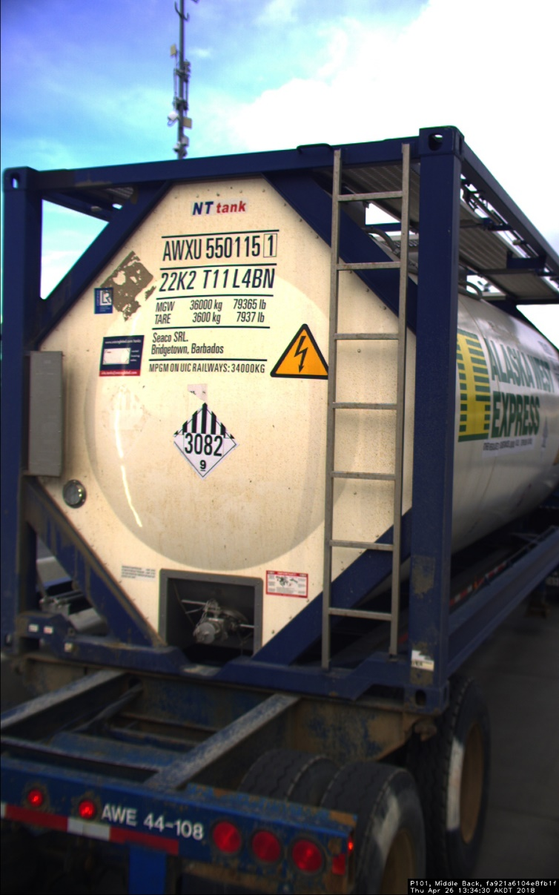

box_ind[0] refers to the 0th box in the image.

The corresponding box co-ordinates are found in the ‘**i**’ th row of the tensor **boxes**.

**tensorflow::ops::CropAndResizeGradBoxes and tensorflow::ops::CropAndResizeGradBoxes::Attrs**

#include <image_ops.h> 🡪 This header file should be included.

Computes the gradient of the crop_and_resize op with respect to the input boxes tensor.

Indicates that the local changes are taken into consideration.

Inputs:

image tensor should be of at least three dimensions.

grads:

[num_boxes, crop_height, crop_width, depth]

Stack of num_boxes – with crop_height, crop_width and depth. In the figure the depth is three, the crop_height and crop_width is understood and the num_boxes denotes the number of boxes present in the image so, repetition of these RGB units forms the 4-D tensor.

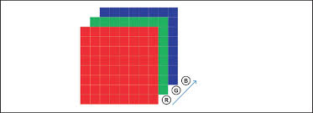

boxes and box_ind are used in same sense as the previous ones.

[CropAndResizeGradBoxes](https://www.tensorflow.org/api_docs/cc/class/tensorflow/ops/crop-and-resize-grad-boxes#classtensorflow_1_1ops_1_1_crop_and_resize_grad_boxes_1acb0082fa9451e89cacb7f33ec41ea71f)(const ::[tensorflow::Scope](https://www.tensorflow.org/api_docs/cc/class/tensorflow/scope.html#classtensorflow_1_1_scope) & scope, ::[tensorflow::Input](https://www.tensorflow.org/api_docs/cc/class/tensorflow/input.html#classtensorflow_1_1_input) grads, ::[tensorflow::Input](https://www.tensorflow.org/api_docs/cc/class/tensorflow/input.html#classtensorflow_1_1_input) image, ::[tensorflow::Input](https://www.tensorflow.org/api_docs/cc/class/tensorflow/input.html#classtensorflow_1_1_input) boxes, ::[tensorflow::Input](https://www.tensorflow.org/api_docs/cc/class/tensorflow/input.html#classtensorflow_1_1_input) box_ind, const [CropAndResizeGradBoxes::Attrs](https://www.tensorflow.org/api_docs/cc/struct/tensorflow/ops/crop-and-resize-grad-boxes/attrs.html#structtensorflow_1_1ops_1_1_crop_and_resize_grad_boxes_1_1_attrs) & attrs)

The Attrs has only one optional parameter as of now.

StringPiece tensorflow::ops::CropAndResizeGradBoxes::Attrs::method_ = "bilinear"

Output:

2-D tensor of shape [num_boxes, 4]

**tensorflow::ops::CropAndResizeGradImage and tensorflow::ops::CropAndResizeGradImage::Attrs**

#include <image_ops.h> 🡪 This header file should be included.

Computes the gradient of the crop_and_resize op with respect to the input image tensor.

Takes the entire image information for gradient computation.